**MODELING THE SPREAD OF A VIRUS**

**ME303 Fall 2021 Project Assignment I**

by

**Tolga Çatak - 2018405144**



**Department of Mechanical Engineering**

**Bogazici University**

**Istanbul, Turkey**

**December 2021**

**Course Instructor:** Asst. Prof. Murat Çelik

**Abstract**

The coronavirus (COVID-19) has been in our lives for more than a year and it has been impacting our lives extremely. In fact, it seems like it will continue to affect our lives as new variants of the virus occur due to mutations. This paper aims to develop a mathematical model for a COVID-19 type epidemic. Although this model does not represent real life precisely, it will provide a good understanding of the situation. With the help of this model, researchers and authorized people can make the right decisions. Furthermore, the different circumstances can also be simulated and forecasted by changing the parameters of the equations.

**1. Introduction**

The simplified mathematical model we will create will include 5 different sub-groups of population.

* Susceptibles *S(t)* : People who are susceptible to the virus.
* Exposed *E(t)* : People who are exposed to the virus.
* Infected *I(t)* : People who are infected by the virus.
* `Medically Symptomatic *M(t)* : People who are medically symptomatic (meaning that this portion of the infected population needs to be hospitalized for a certain period of time)
* Recovered *R(t)* : People who are recovered from the disease.

The simplified mathematical model is as follows:

*= -cβ S*

*= cβ S – αE*

*= -αE – γI*

*= γI – ωM*

*= ωM*

with the initial conditions

*S*(0) = 10000

*E*(0) = 10

*I*(0) = 0

*M*(0) = 0

*R*(0) = 0

For

ti = 0 ≤ t ≤ tf  = 100 days

where

* *c* is the encounter rate in encounters per day (assume *c* = 4 encounters/day),
* *β* is the transmission probability per encounter (assume *β* = 0.2),
* *α* is the rate at which infected become infectious (i.e. *α* is the inverse of the incubation time) in 1/days (assume incubation time to be 8 days, so *α*= 1/8 = 0.125 per day),
* *γ* is the rate at which an infected person becomes symptomatic (i.e. *γ* is the inverse of the time it takes to be symptomatic) in 1/days (assume that the time it takes to be symptomatic to be 10 days, so *γ* = 1/10 = 0.1 per day),
* *ω* is the rate at which the person recovers (i.e. *ω* is the inverse of the time it takes to recover) in 1/days (assume that the time it takes to recover to be 5 days, so *ω* = 1/5 = 0.2 per day).

Assume also that the available hospitals beds, Nbed, are 1000.

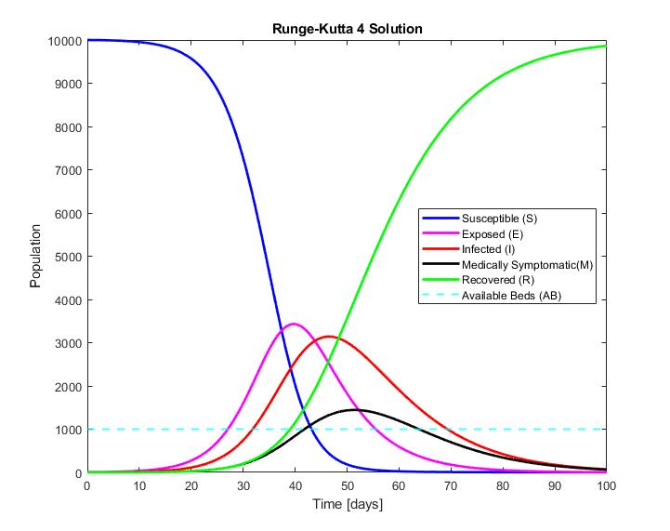With the given parameters, the generated graph is given below in figure 1.

**Figure 1.** RK-4 Solution with *c*=4, *β*=0.2, *α*=0.125, *γ*=0.1, *ω*=0.2.

*β*

*α*

*γ*

*ω*

*β*

*α*

*γ*

*ω*

*β*

*α*

*γ*

*ω*

**2. Effect of the Parameters on the Outcome**

In this section, we will investigate how each parameter affects the outcome of the epidemic and which parameters have big effect on the outcome. In our model, we will use the Runge-Kutta 4 method with h=1/500. We will look at the parameters one by one and not consider other effects. We will discuss the validity of the assumptions in the following sections.

**2.1 Effect of the Encounter Rate per Day**

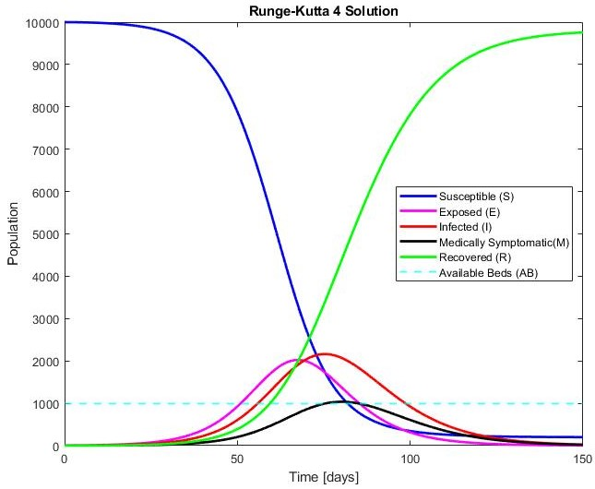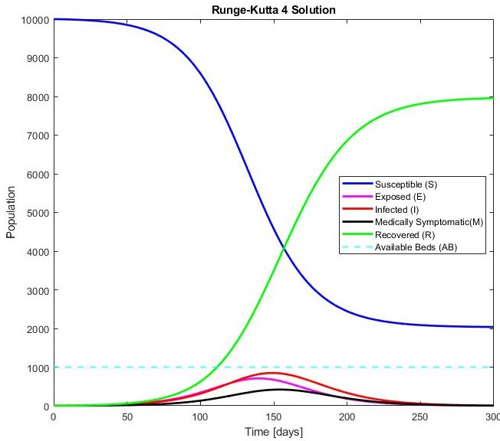We will start with the effect of the encounter rate. The following graphs have the same parameters as the given parameters except c. c is equal to 1, 2, 8 and 32 respectively.

**Figure 2.** RK-4 Solution with *c*=1, *β*=0.2, *α*=0.125, *γ*=0.1, *ω*=0.2.

*β*

*α*

*γ*

*ω*

*β*

*α*

*γ*

*ω*

*β*

*α*

*γ*

*ω*

**Figure 3.** RK-4 Solution with *c*=2, *β*=0.2, *α*=0.125, *γ*=0.1, *ω*=0.2.

*β*

*α*

*γ*

*ω*

*β*

*α*

*γ*

*ω*

*β*

*α*

*γ*

*ω*

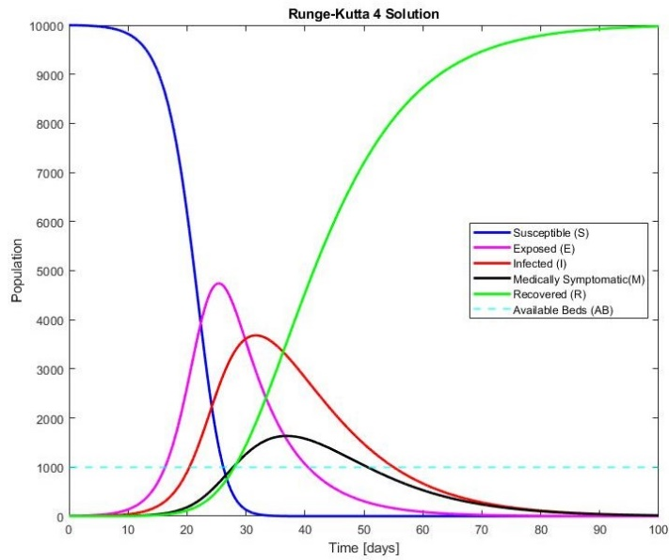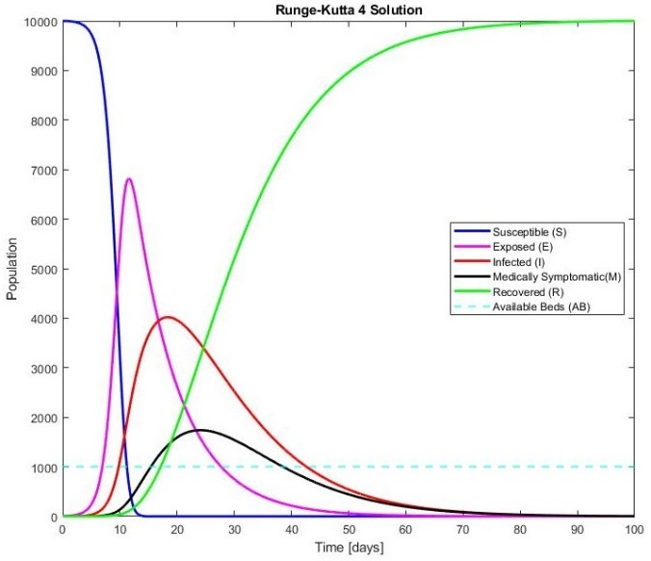

**Figure 4.** RK-4 Solution with *c*=8, *β*=0.2, *α*=0.125, *γ*=0.1, *ω*=0.2.

*β*

*α*

*γ*

*ω*

*β*

*α*

*γ*

*ω*

*β*

*α*

*γ*

*ω*

**Figure 5.** RK-4 Solution with *c*=32, *β*=0.2, *α*=0.125, *γ*=0.1, *ω*=0.2.

*β*

*α*

*γ*

*ω*

*β*

*α*

*γ*

*ω*

*β*

*α*

*γ*

*ω*

As can be seen from the figures above, the encounter rate affects the outcome substantially. As the encounter rate increases; the peaks of the exposed, infected, and medically symptomatic curves are reached earlier meaning that the virus is spreading among the society much faster. Not surprisingly, as the encounter rate is decreasing, the curves flatten, and the peek values decrease meaning that the virus is spreading slowly. Although at first glance it may seem like it is better to get over with the disease earlier, this could have crucial outcomes. This was the strategy of the Swedish government during the first times of the COVID-19 epidemic. They did not try to decrease the encounter rate with nationwide shutdowns but instead tried to make a large portion of their population immune, i.e., “herd immunity”. However, this idea was not successful due to various reasons as mutants and insufficient hospital beds, etc.

If we examine the figures, we can see that when the encounter rate is equal to 4, 8 and 32, the number of people who are medically symptomatic is beyond the capacity of the hospitals for days or even weeks. Thus, people who should have been bedded in hospitals are not taken care of thoroughly due to hospitals being overwhelmed. This could result in deaths.

However, if we examine the figures with c=1 and c=2, we can see that the number of medically symptomatic people is always less than the available hospital beds. This is the reason why governments all around the globe are trying to decrease the encounter rate by lockdowns, intensives for working from home, online education, entertainment restraints.

Another important point that may be overlooked is the number of infected people. If we examine the figures, we can see that the infected people also decrease with the decreasing encounter rate. Even though they can recover and can be taken care of in hospitals, we do not know the long-term effects of the coronavirus. Therefore, the fewer the number of infected people, the better it is.

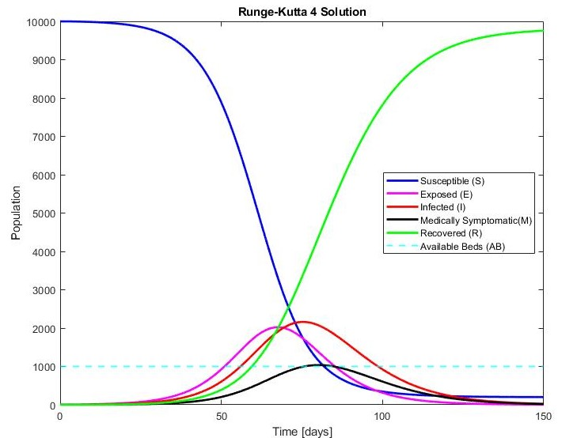**2.2 Effect of the Transmission Probability per Encounter**

**Figure 6.** RK-4 Solution with *c*=4, *β*=0.1, *α*=0.125, *γ*=0.1, *ω*=0.2.

*β*

*α*

*γ*

*ω*

*β*

*α*

*γ*

*ω*

*β*

*α*

*γ*

*ω*

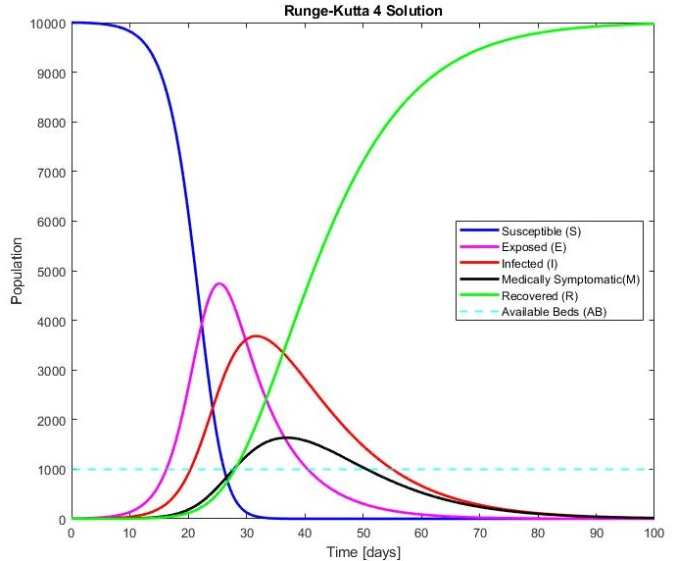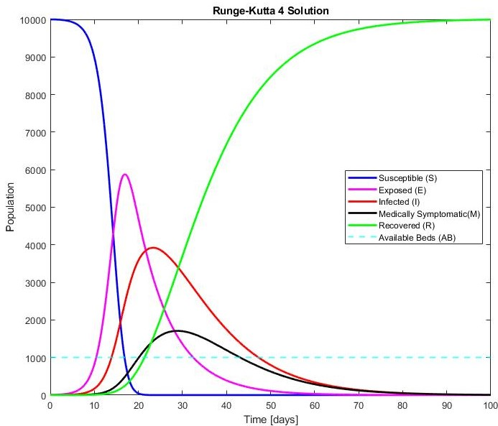

**Figure 7.** RK-4 Solution with *c*=4, *β*=0.4, *α*=0.125, *γ*=0.1, *ω*=0.2.

*β*

*α*

*γ*

*ω*

*β*

*α*

*γ*

*ω*

*β*

*α*

*γ*

*ω*

**Figure 8.** RK-4 Solution with *c*=4, *β*=0.8, *α*=0.125, *γ*=0.1, *ω*=0.2.

*β*

*α*

*γ*

*ω*

*β*

*α*

*γ*

*ω*

*β*

*α*

*γ*

*ω*

As seen in the 3 figures above, the transmission probability also affects the outcome significantly. As in the case of the encounter rate, the peaks of the exposed, infected, and medically symptomatic curves are reached earlier when the transmission probability is decreased. Due to similar reasons, the aim is to lower the transmission rate so that the situation can be kept under control. That is why there are mandatory rules and intensives about social distancing, mask-wearing, and increasing hygiene measurements. There are also some restrictions about the closed area ventilation and person limitation.

For instance, the latest peaks in the coronavirus cases in many countries are related to the new variant called ‘Omicron’, which is thought to have a higher transmission probability than other variants. Therefore, many countries are imposing new restrictions on the New Year Celebrations. This is also the reason why our university (Bogazici University) has decided to switch to online education for the last 2 weeks of the semester.

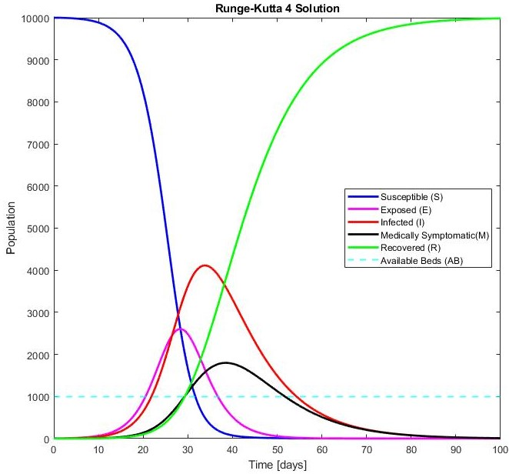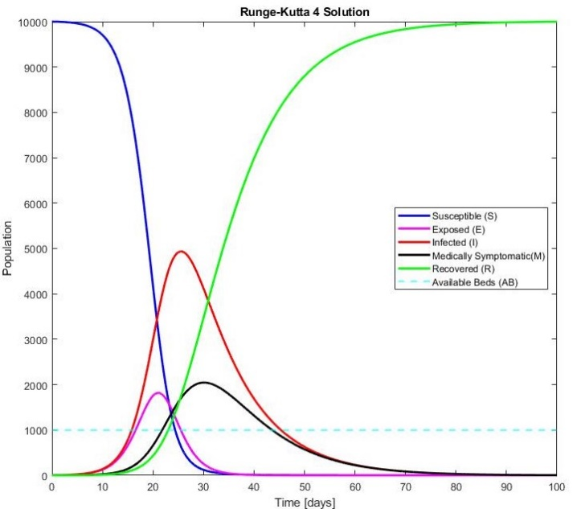**2.3 Effect of the Rate at which Infected Become Infectious**

**Figure 10.** RK-4 Solution with *c*=4, *β*=0.2, *α*=0.25, *γ*=0.1, *ω*=0.2.

*β*

*α*

*γ*

*ω*

*β*

*α*

*γ*

*ω*

*β*

*α*

*γ*

*ω*

**Figure 9.** RK-4 Solution with *c*=4, *β*=0.2, *α*=0.5, *γ*=0.1, *ω*=0.2.

*β*

*α*

*γ*

*ω*

*β*

*α*

*γ*

*ω*

*β*

*α*

*γ*

*ω*

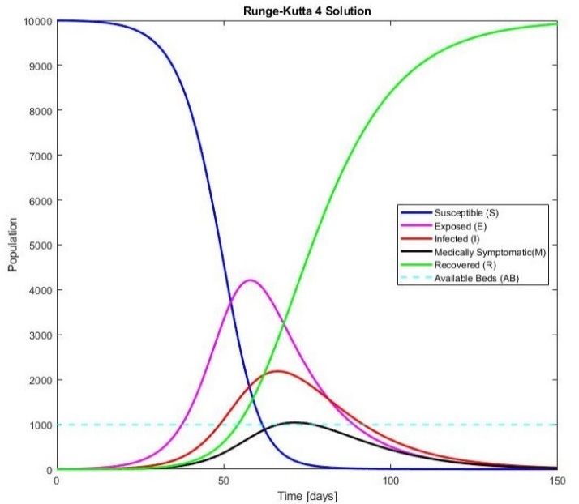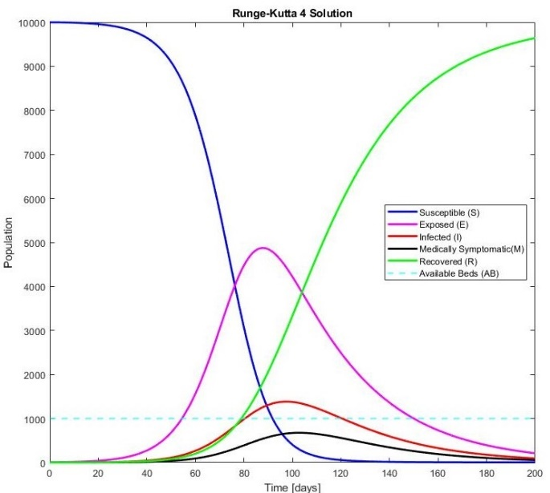

**Figure 12.** RK-4 Solution with *c*=4, *β*=0.2, *α*=0.03125, *γ*=0.1, *ω*=0.2.

*β*

*α*

*γ*

*ω*

*β*

*α*

*γ*

*ω*

*β*

*α*

*γ*

*ω*

**Figure 11.** RK-4 Solution with *c*=4, *β*=0.2, *α*=0.0625, *γ*=0.1, *ω*=0.2.

*β*

*α*

*γ*

*ω*

*β*

*α*

*γ*

*ω*

*β*

*α*

*γ*

*ω*

Although the main criteria we should be looking at is whether the number of medically symptomatic people exceeds the number of available beds or not, the number of infected people is also important due to the reasons mentioned above.

If we examine the 4 figures above, we can say that the rate at which infected become infectious or i.e., the incubation time of a virus plays an immense role in the number of infected people. As the rate increases (the incubation time decreases), the number of infected people is increasing vastly. In fact, for values bigger than 0.125 (fewer days than 7 days), the number of infected people is more than the number of people who are exposed. Furthermore, as more people get infected, the number of medically symptomatic people is also increasing and exceeds the number of available beds during peak times.

Moreover, the incubation time is important for determining the quarantine durations. Since it is not certain if someone exposed has the disease or not, they should be in lockdown until it is certain, and it will be certain after the incubation time has passed. The incubation time of the first variants of the COVID-19 is changing between 2.87 days and 17.6 days, although it is rarely longer than 14 days. Therefore, the duration of the lockdown is 14 days in most countries.

The first research made about the first variants that appeared in the mainland of China showed that the average incubation time was 8.0 days. However, with the newer variants, the incubation time is decreasing. Research shows that non-Delta infections have a mean of 5.0 days of incubation time while Delta variants have a mean of 4.3 days. Thus, some countries have been decreasing their lockdown times. For instance, lockdown in Turkey is 10 days instead of 14 and England has decreased it to 7 days instead of 10 days.

Additionally, for the time being, the latest and the most impactful variant may have even less incubation time. Although there are not many research and data about the omicron variant, according to the recent analysis from the UK Health Security Agency, the shorter incubation time is one of the reasons why it has a higher transmission rate. This results in the higher peak values reached in a shorter period as the graphs suggest. Since governments, do not want their health systems to be overwhelmed as in the case of figure 8 and figure 9, they are launching more precautions and lockdowns again. For instance, on 19th December 2021, the Netherlands decided to implement lockdown until January 14th, 2022, which is more than 3 weeks.

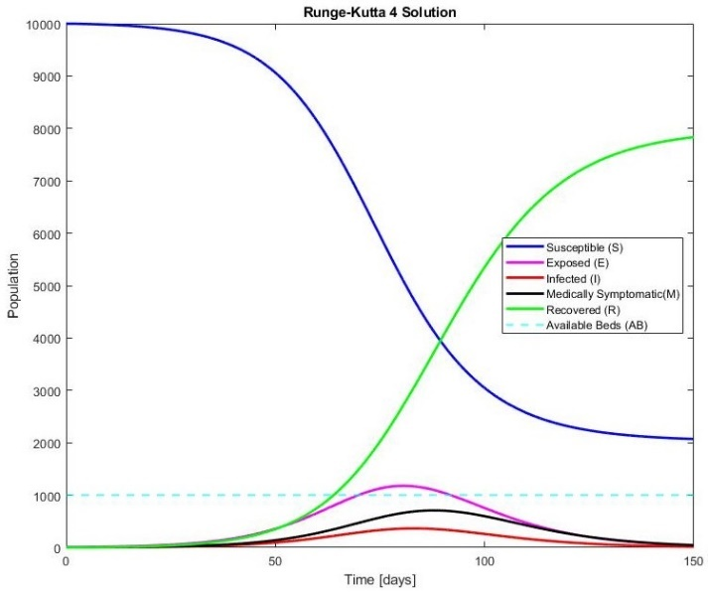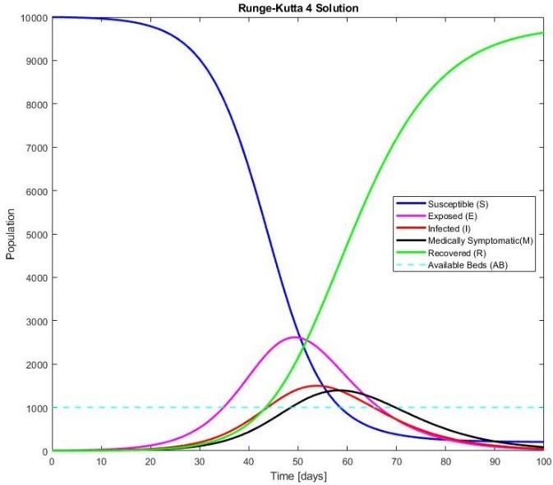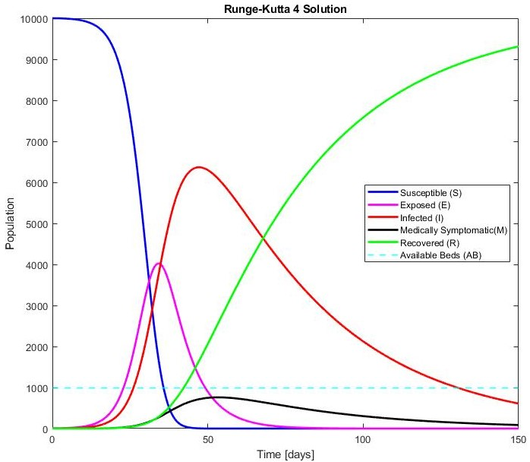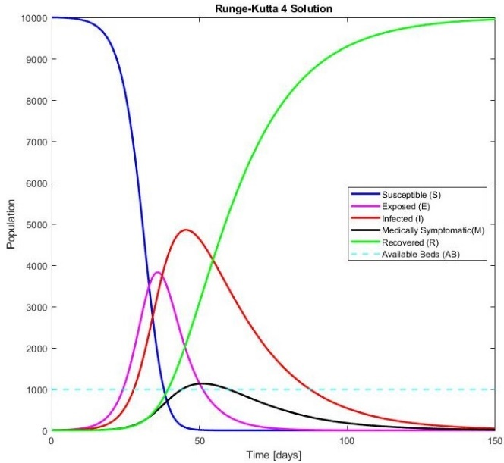**2.4 Effect of the Rate at which Infected Person become Symptomatic**

**Figure 14.** RK-4 Solution with *c*=4, *β*=0.2, *α*=0.125, *γ*=0.05, *ω*=0.2.

*β*

*α*

*γ*

*ω*

*β*

*α*

*γ*

*ω*

*β*

*α*

*γ*

*ω*

**Figure 15.** RK-4 Solution with *c*=4, *β*=0.2, *α*=0.125, *γ*=0.2, *ω*=0.2.

*β*

*α*

*γ*

*ω*

*β*

*α*

*γ*

*ω*

*β*

*α*

*γ*

*ω*

**Figure 16.** RK- 4 Solution with *c*=4, *β*=0.2, *α*=0.125, *γ*=0.4, *ω*=0.2.

*β*

*α*

*γ*

*ω*

*β*

*α*

*γ*

*ω*

*β*

*α*

*γ*

*ω*

**Figure 13.** RK-4 Solution with *c*=4, *β*=0.2, *α*=0.125, *γ*=0.025, *ω*=0.2.

*β*

*α*

*γ*

*ω*

*β*

*α*

*γ*

*ω*

*β*

*α*

*γ*

*ω*

The rate at which an infected person becomes symptomatic is an important parameter for the number of infected people. As it gets longer to be symptomatic, the number of infected people increases significantly. This could be important in the long term as the long-term effects of the coronavirus are unknown. Or it could be important from the economic point of view, as there could be a lot of small-scale lockdowns in schools or workplaces etc. However, it is not as important as other parameters from the health system’s point of view since the medically symptomatic people do not change as considerably.

On the other hand, this could be an important parameter in real life even if it is not that important in this simplified model. If people show symptoms earlier, this could help officials to do a better job in contact tracing and thus help them control the spread of the virus. It is also helpful for people in general since they can self-quarantine when they show symptoms instead of having the risk to infect other people while not showing symptoms.

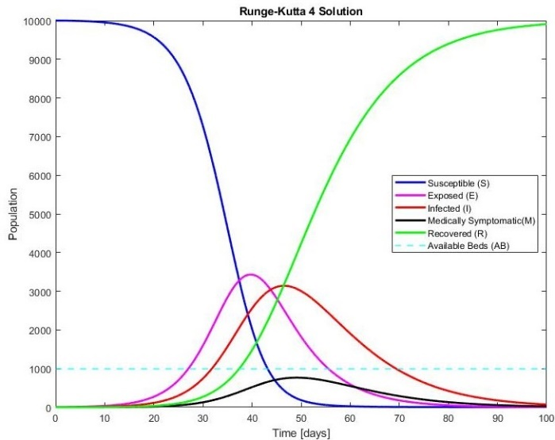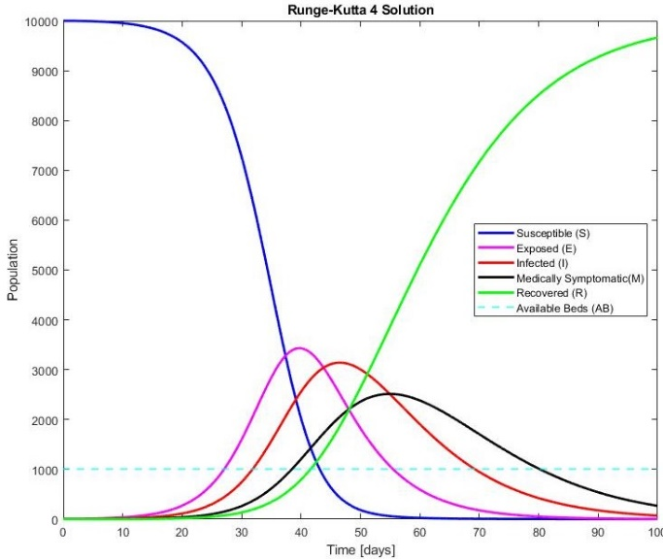**2.5 Effect of the Rate at which the Person Recovers**

**Figure 18.** RK- 4 Solution with *c*=4, *β*=0.2, *α*=0.125, *γ*=0.4, *ω*=0.4.

*β*

*α*

*γ*

*ω*

*β*

*α*

*γ*

*ω*

*β*

*α*

*γ*

*ω*

**Figure 17.** RK-4 Solution with *c*=4, *β*=0.2, *α*=0.125, *γ*=0.1, *ω*=0.1.

*β*

*α*

*γ*

*ω*

*β*

*α*

*γ*

*ω*

*β*

*α*

*γ*

*ω*

Looking at the figures above, we can say that the time it takes to recover is one of the most important parameters if not the most. Even though it does not affect the number of exposed and infected people, it directly affects the number of medically symptomatic people which is the most important thing for the health system. Since people that are already medically symptomatic are not healing and the beds in the hospital cannot be used, the new medically symptomatic people cannot have the necessary treatment.

It can also impact the daily life of the people. When the recovery times get longer, people must be away from their schools, works, and other mandatory daily things. This would also affect their psychological health in addition to their physical health.

**3. Assumptions and Their Validity**

After we have investigated the effects of the different parameters on the situation, we will discuss the assumptions we have made and their validity. Firstly, we will discuss the validity of the parameters we have introduced and then we will discuss other parameters that may influence the situation.

**3.1 Validity of the Constant ‘c’**

To begin with, we assumed that ‘c’ is not changing with time. This means that everybody encounters the same number of people in a day. However, this is not the case in real life. For example, healthcare professionals encounter tens of people in a day while a person working from home does not have to encounter anyone. This also differs from society to society as the number of interactions between people is not the same in a city as in a small town. Although we have a small population (10000) and possibly a homogeneous one in this model, this is not the case in real life. Therefore, we can say that the constant ‘c’ assumption is not very valid in large societies with nonhomogeneous distributions but may be valid in small societies.

**3.2 Validity of the Constant ‘β’**

In our model, we assumed that ‘β’ is constant for a given value. This means that everybody has the same probability to spread the virus. However, in real life, some people are much more careful with their hygiene and have more awareness for others. This can change from person to person as well as from society to society. Furthermore, the viruses are changing constantly as new variants that have various characteristics appear. Thus, we can say that the constant ‘β’ assumption may be valid for a type of virus if we consider the mean value for the society, however, it is not valid in general due to different virus types and their nonhomogeneous distributions in the population.

**3.3 Validity of the Constant ‘α’**

Moreover, we assumed that ‘α’ is constant for a given value. This means that the incubation time is the same for everyone. It is certain that the incubation time varies from person to person as well as from one virus variant to another virus variant. Similar to the ‘β’, the mean can be considered in a society for a virus variant, however, the distribution of the various variants should also be considered in real life. Hence, we can say that it is not valid for the real-life model.

**3.4 Validity of the Constant ‘γ’**

In our model, we assumed that ‘γ’ is constant for a given value. This means that everybody who is infected will become symptomatic in a certain amount of time. This is also dependent on people’s health as everybody does not have the same strength of health and immune system. People of different ages, with different genetics and pre-existing health problems, will become symptomatic at different times. This will also be different for the same person with different variants. Additionally, this model does not consider the fact that some people will not show symptoms at all. This will not be the case in real life, there are a lot of people who are asymptomatic but still spread the disease. Therefore, this assumption is also not very valid.

**3.5 Validity of the Constant ‘ω’**

We also assumed that the recovery time is the same for everyone. However, due to people having different ages, sex, genetics, immune systems, pre-existing health problems, etc., the time it takes to recover also varies. While some people do not show any symptoms, some people feel sick for days or even weeks. In fact, it is known that some of the symptoms such as the loss of taste and smell continue for months. We can take the mean value for the recovery time, but this would not represent real life due to societies being very heterogeneous. Thus, this assumption is also not very valid.

**3.6 Other Factors to Consider**

In addition to the factors, we discussed above, we also take into account the factors that are not related to the listed parameters. Firstly, we did not introduce any parameters or a sub-group for people who die from the disease. In real life, people will die due to the disease, and this will cause a natural selection since mostly unhealthy or old people will die. Furthermore, the virus will also evolve according to the natural selection rules. This may be one of the most important defects of our model.

There are also newborn people that we didn’t consider. This has of course very little impact on the situation in our model since we considered between 0-100 days in most of the situations. Nonetheless, considering that it has been 21 months since the epidemic began and it will probably continue for at least a few more months, it is an important aspect to evaluate in real life.

Although we mentioned the effect of the pre-existing health problems, it is an important point to touch upon. People who have comorbidities such as cancer, diabetes, heart problems, kidney problems, obesity are more likely to be medically symptomatic and die. This phenomenon is not only affecting the parameters and the distribution of the subgroups, but also the reliability of the actual data since some countries tend to express the cause of death as the pre-existing health problem even though the death is due to the coronavirus, thus manipulating the COVID-19 statistics.

Another important effect on the situation is the vaccines. There are several vaccines developed in various countries and billions of people have been vaccinated at least one dose. Vaccines have a different amount of protection against different variants. Additionally, the distribution of vaccinated people is not homogeneous in a society and the number of doses is not the same for everyone. Our model does not consider this factor and differs from real life in that matter.

One of the most important assumptions we made is that the society we are examining is closed meaning that there are not any interactions with the outside world. However, in real life people travel due to numerous reasons and interact with people from all around the world. With the advanced technology, these interactions are more than ever and are probably the number one reason that COVID-19 is a worldwide problem. The high mobility of the people causes the virus to spread faster and make our model invalid in real life. However, our model would be still valid for a closed population, i.e., a group of quarantined people.

Finally, we did not consider the seasonal effects in our model. It is known that the cases are increasing in winter while decreasing in summer since coronaviruses can survive longer in environments of lower humidity, lower temperatures, and decreased sunlight. Also, the immune systems get weak from other diseases such as flu and cold, causing more severe consequences of the COVID-19 during winter times. The graphs of new cases, newly hospitalized people, and 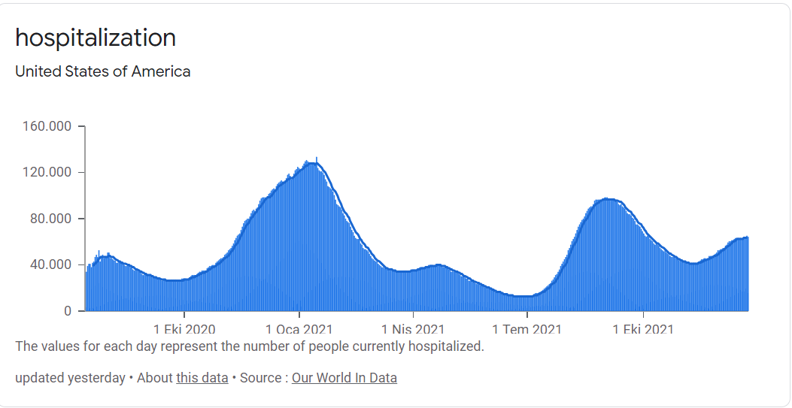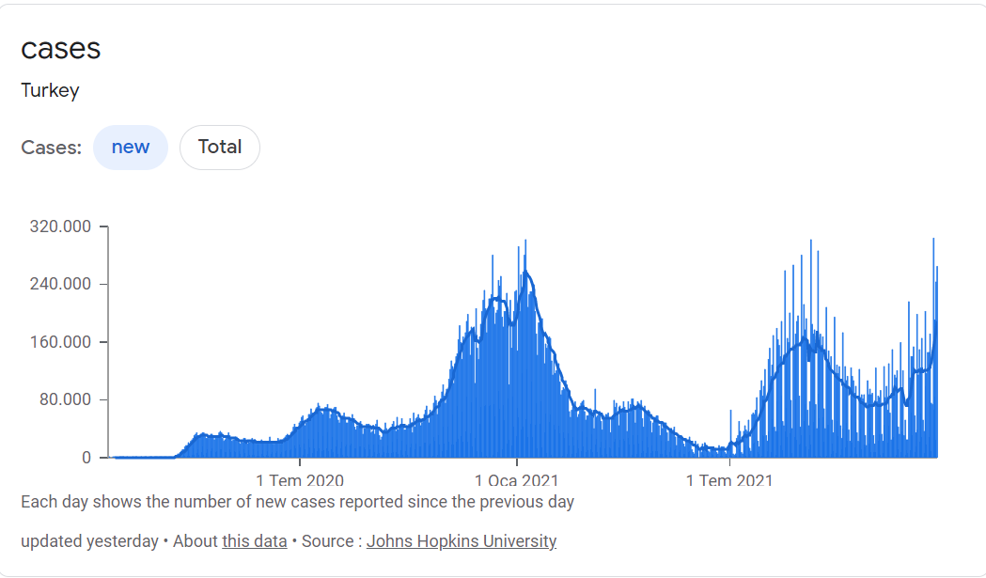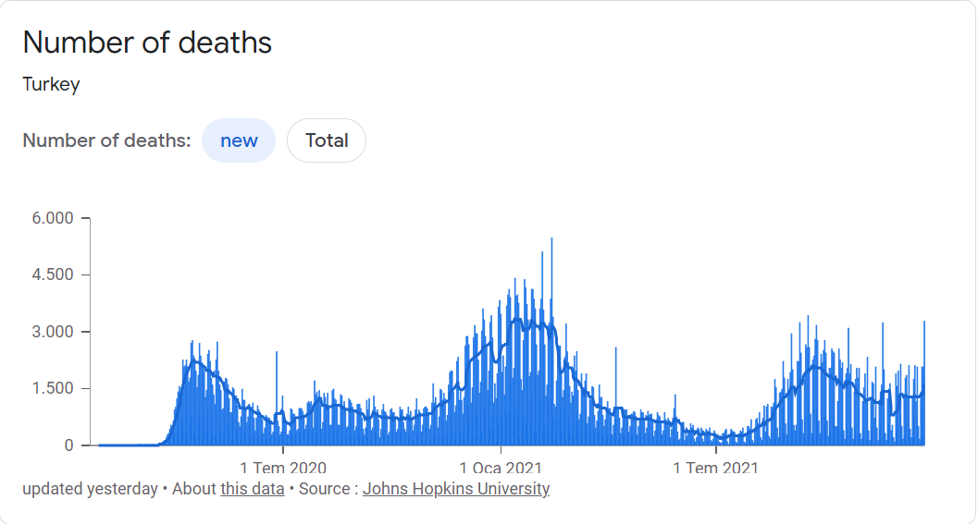death vs. time graphs are given below.

**Figure 20.** Number of hospitalized people vs. time graph in the US.

*β*

*α*

*γ*

*ω*

*β*

*α*

*γ*

*ω*

*β*

*α*

*γ*

*ω*

**Figure 19.** Number of new cases vs. time graph in the US.

*β*

*α*

*γ*

*ω*

*β*

*α*

*γ*

*ω*

*β*

*α*

*γ*

*ω*

**Figure 21.** Number of deaths due to COVID-19 vs. time graph in the US.

*β*

*α*

*γ*

*ω*

*β*

*α*

*γ*

*ω*

*β*

*α*

*γ*

*ω*

From the figures above, it is clear that the COVID-19 problem becomes more serious in the winter and its effect weakens during summer times.

Moreover, the environment is another important effect. The weather, air, and water pollution differ from country to country which has some minor effects on the outcome. This can differ in a country as well. A good example of this is the Zonguldak city in Turkey. Even though the number of cases was relatively low, it was counted as a risky city since many people work in coal mines in Zonguldak and have bad lung health. Therefore, during lockdown times Zonguldak was also subjected to strict restraints. We also did not take these factors into account and our model lacks reality in this regard.

**4. Conclusion**

In this paper, we developed a model to represent the COVID-19 epidemic and changed various parameters to see what the outcome would be. We used MATLAB to visualize the situation with graphs. Then, we discussed the validity of those parameters and the assumptions we have made. Even though we listed many things why our model is not the perfect model to represent the real life, it is impossible to represent real life with any other models as well. Officials and decision-makers can use the results from our model and blend them with the other factors such as economic concerns, educational concerns, political concerns, etc. They can also adjust the parameters with the real life data and correlate the model with real life better. To conclude, our model does a decent job for providing a good understanding of the circumstances and the effects of different parameters.

**References**

|  |  |
| --- | --- |
| [1] | "Coronavirus in the U.S.: Latest Map and Case Count," The New York Times, [Online]. Available: https://www.nytimes.com/interactive/2021/us/covid-cases.html. [Accessed 23 12 2021]. |
| [2] | B. By Sally Robertson, "“Herd immunity” not responsible for Sweden’s control of COVID-19, say researchers," 14 07 2021. [Online]. Available: https://www.news-medical.net/news/20210714/e2809cHerd-immunitye2809d-not-responsible-for-Swedene28099s-control-of-COVID-19-say-researchers.aspx. |
| [3] | Carly J Wood, Jo Barton, Nina Smyth, "A cross-sectional study of physical activity behaviour and associations with wellbeing during the UK coronavirus lockdown," *Journal of Health Psychology,* 2021. |
| [4] | Bilimsel Danışma Kurulu, "COVID-19 Salgın Yönetimi ve Çalışma Rehberi," T.C. Sağlık Bakanlığı, Ankara, 2021. |
| [5] | Cheng Cheng, DongDong Zhang, Dejian Dang, Juan Geng, Peiyu Zhu, Mingzhu Yuan, Ruonan Liang, Haiyan Yang, Yuefei Jin, Jing Xie, Shuaiyin Chen & Guangcai Duan , "The incubation period of COVID-19: a global meta-analysis of 53 studies and a Chinese observation study of 11 545 patients," *Infectious Diseases of Poverty,* no. 119, 2021. |
| [6] | Rebecca Grant, Tiffany Charmet, Laure Schaeffer, Simon Galmiche, Yoann Madec, Cassandre Von Platen, "Impact of SARS-CoV-2 Delta variant on incubation, transmission settings and vaccine effectiveness: Results from a nationwide case-control study in France," *The Lancet Regional Health,* 2021. |
| [7] | "T.C. Sağlık Bakanlığı COVID-19 Bilgilendirme Platformu," T.C. Sağlık Bakanlığı, [Online]. Available: https://covid19.saglik.gov.tr/. [Accessed 23 12 2021]. |
| [8] | "UK reduces COVID-19 self-isolation to 7 days for most in England," Reuters, 23 12 2021. [Online]. Available: https://www.reuters.com/business/healthcare-pharmaceuticals/uk-reduces-covid-19-self-isolation-7-days-most-england-2021-12-22/. [Accessed 23 12 2021]. |
| [9] | "Dutch measures against COVID-19," Government of the Netherlands, [Online]. Available: https://www.government.nl/topics/coronavirus-covid-19/tackling-new-coronavirus-in-the-netherlands. [Accessed 23 12 2021]. |
| [10] | John Middleton, Henrique Lopes, Kai Michelson & John Reid , "Planning for a second wave pandemic of COVID-19 and planning for winter," *International Journal of Public Health,* no. 65, 2020. |
| [11] | A. Mitropoulos, "Why experts say COVID threat looms with winter," abc News, 12 11 2021. [Online]. Available: https://abcnews.go.com/Health/experts-covid-threat-looms-winter/story?id=80979325. [Accessed 23 12 2021]. |